

Compliance Vault Solution Brief

ProvenDB Compliance Vault

Solution Brief

# Background

Almost all businesses are regulated by government agencies. For instance, any US business that pays tax will have regulatory requirements to the Inland Revenue Service (IRS) and any US business that has employees will have regulatory obligations with the Department of Labor. Many companies have additional regulatory compliance responsibilities arising from bodies that regulate prudential risk, securities, consumer rights and so on.

Compliance with regulation has always involved time-consuming and costly reporting and recordkeeping requirements. This cost is justified by the serious consequence of non-compliance: legal proceedings, fines and penalties, and the loss of income and reputation.

However, in the wake of the widespread mispracties that lead to the Global Financial Crisis and following revelations of regulatory misconduct across multiple industries worldwide, regulators are increasingly seeking higher standards of proof when dealing with compliance data. Digital information is simply too easy to fabricate, tamper, or delete. Therefore, regulators are increasingly unwilling to take regulated entities on trust: they require proof.

Consequently, both the costs of compliance and the risks of non-compliance are increasing.

**ProvenDB Compliance Vault** is a cost-effective software solution that provides a tamper-resistant digital store for your critical compliance information. The ownership and creation date of information stored in ProvenDB Compliance Vault can be definitively proven by stringent industry-standard cryptography. With ProvenDB Compliance Vault, you can be certain that your compliance data will satisfy the most rigorous compliance audit.

# Cost of Non-Compliance

The most common issue for regulated entities is not evidence of non-compliance; rather, it’s an inability to *prove* compliance. For instance, in Australia a Royal Commission into banking misconduct found that certain big banks could not “readily identify how, or to what extent, the entity as a whole was failing to comply with the law.” At least 20 executives and directors of financial institutions lost their jobs in the fall out from the Australian Commission. It’s widely expected that upcoming investigations will find similar issues across almost all industries.

Maintaining compliance documentation in a central data store is an obvious measure that an organization can establish. However, regulators require far more than a simple collection of relevant documents. For instance, the following APRA guidelines clearly articulate the high bar for data integrity (our emphasis):

*Auditability (the ability to* ***confirm the origin of data*** *and provide* ***transparency of all alterations****) is a key element to verifying data quality. It involves the examination of data and associated audit trail, data architecture and other supporting material. APRA envisages that a regulated entity would ensure that* ***data is sufficiently auditable*** *in order to satisfy the entity's business requirements (including regulatory and legal), facilitate independent audit, assist in* ***dispute resolution (including non-repudiation)*** *and* ***assist in the provision of forensic evidence*** *if required[1]*

# Introducing ProvenDB Compliance Vault

ProvenDB Compliance Vault is a data storage solution that fully complies with the strictest regulator's data handling requirements. Documents stored in a ProvenDB Compliance Vault incorporate indisputable proof of origin date, cryptographic signatures proving document ownership, unbreakable tamper-detection, and complete visibility into all document modifications. ProvenDB Compliance Vault can be used as a cloud service or can be deployed on-premise. The entry-level pricing is less than that of a premium Netflix subscription, making it both the cheapest and most effective way to prove the integrity of your critical compliance documents.

ProvenDB Compliance Vault serves as the repository of record for all critical compliance documentation. This includes:

* Board minutes and resolutions
* Receipts, invoices and other documents supporting tax claims
* Anti-Money Laundering and Counter-Terrorism Financing records
* Know Your Customer (KYC) documents
* Credit Reporting Privacy disclosures and activities
* Contracts, applications and all materials that form the basis of a financial credit assessment
* Timesheets and employment records
* Certifications
* Personal Information Consents
* Significant email trails,

# How it Works

When a document or data record is added to ProvenDB Compliance Vault, cryptographic signatures of the document are created. These signatures can be “signed” by your company’s cryptographic key (possibly the same key that guarantees the identity of your website). These signatures are aggregated and anchored to a public Blockchain such as Bitcoin or Ethereum.

Once anchored to the public Blockchain, the signatures form an impeccable and irrefutable proof of document state and origin time. The Blockchain record – which cannot be altered by any known technology – proves the overall integrity and timestamp of items in the Vault, eliminating any possibility of undetected tampering or backdating.

Alterations to documents in the Vault create new versions of the documents – preserving the contents and proof of the previous versions and providing a complete historical view of document changes.

Documents held within a ProvenDB Compliance Vault, therefore, meet the highest levels of regulatory compliance:

* Irrefutable proof of the origin date of the document
* Non-repudiation of documents
* Audibility and transparency of all alterations
* Complete tamper detection
* Cryptographic certificates confirming data ownership, date of origin and integrity

# Deployment Options

You can use ProvenDB Compliance Vault on-premise or as a cloud service.

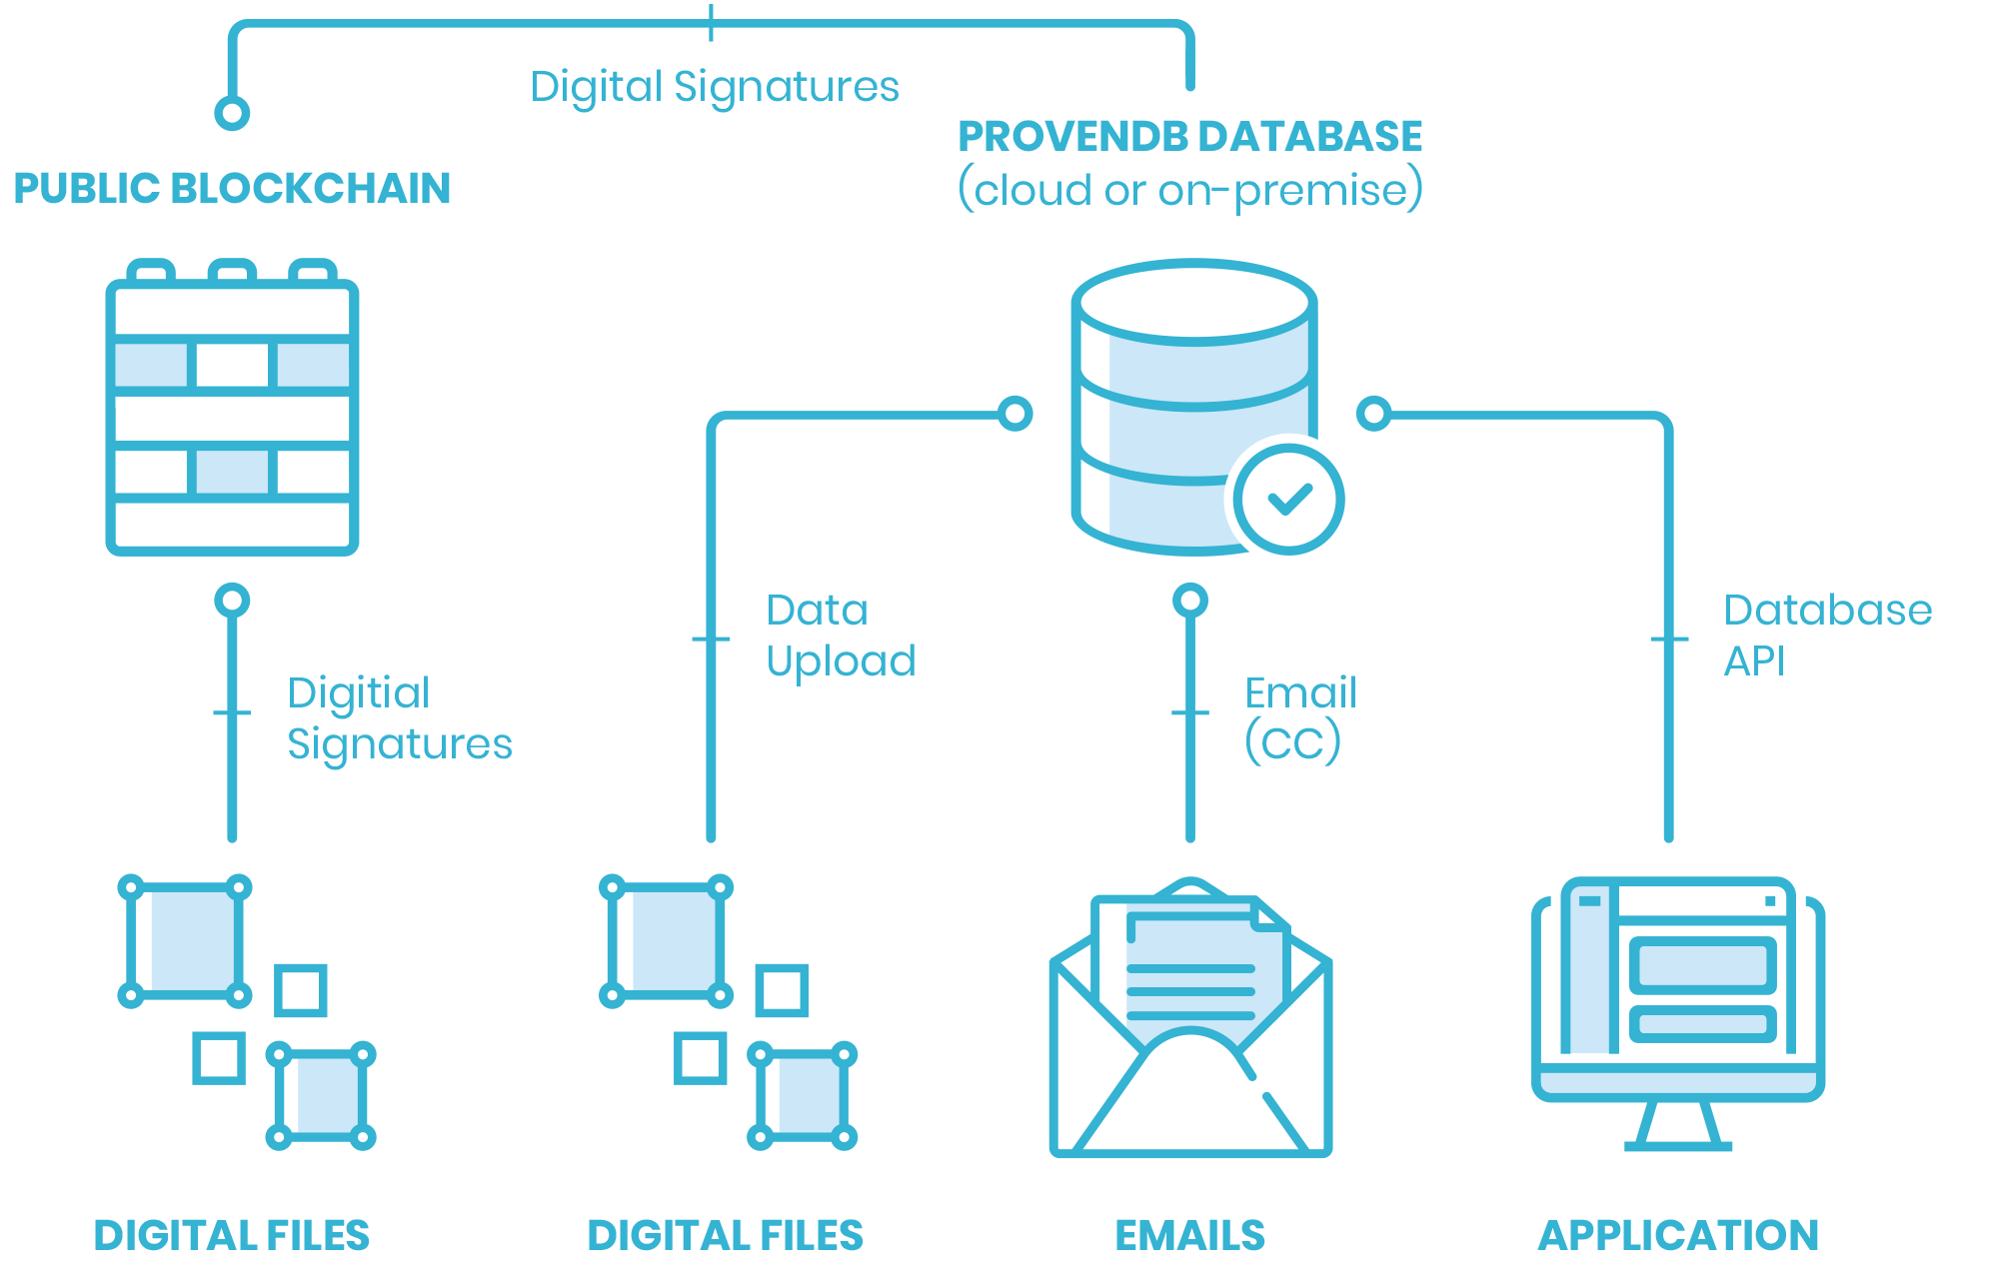The ProvenDB cloud service is the easiest and, operationally, the cheapest deployment option. Data resides in a fully managed cloud database that supports industry-standard encryption and security measures. Data can be uploaded to the Vault using a variety of tools, both command line and a “drag and drop” web interface. Documents can even be added to the cloud service by emailing them from a registered account.

An on-premise deployment supports organizations whose security procedures prohibit the storage of sensitive information in the cloud. In this scenario, all elements of the ProvenDB Compliance Vault are installed within the customer’s data center. This aggregated digital signature is the only element that leaves the customer data center since the signature must be listed on a public Blockchain. However, these signatures are 256-bit numbers which cannot be converted to any meaningful data and which contain no identifiable information (not even the source of the transaction can be deduced from the signature).

The ProvenDB Compliance Vault filesystem utility can be used to create a Vault from an existing, self-managed, file system. Using this utility, you can create digital signatures for files within an existing directory structure. The utility can generate cryptographic proofs of data integrity, date or origin, and ownership as required. In each of these scenarios, document data and cryptographic proofs can be exported to an open format, ensuring that your compliance proofs remain valid even should you cease to use the ProvenDB Compliance Vault.

# Regulatory Compliance Does Not Have To Be A Threat

The costs of non-compliance can be massive: by one estimate, the average cost for organizations that experience non-compliance problems is $14.82 million[2]!.

ProvenDB Compliance Vault both reduces the cost of compliance and the risks and costs of non-compliance.

Using ProvenDB Compliance Vault, you can easily and cheaply establish a repository of compliance information that is secure, tamper-proof and completely provable. Regulators can be shown that the information in the Vault is completely immune from falsification, backdating or tampering. Within your organization, the possibility of insider manipulation of compliance data will be eliminated. The costs and risks involved in compliance audits and regulatory reviews will be minimized.

ProvenDB Compliance Vault is simply the smartest, fastest, and most economical way to prove the integrity of your critical compliance data.

*Eliminate the costs and risks involved in regulatory compliance with ProvenDB Compliance Vault.  
Visit* [*www.provendb.com*](http://www.provendb.com) *to sign up for a ProvenDB cloud service, or email us at* [*support@provendb.com*](mailto:support@provendb.com) *to explore options for deploying ProvenDB Compliance Vault within your organization.*

1. <https://www.apra.gov.au/sites/default/files/Prudential-Practice-Guide-CPG-235-Managing-Data-Risk_1.pdf>
2. <https://www.corporatecomplianceinsights.com/true-cost-compliance/>